
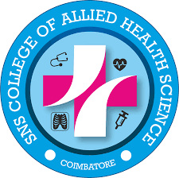
SNS COLLEGE OF ALLIED HEALTH SCIENCE –COIMBATORE

S.No. | NAME OF THE MEMBER | DESIGNATION | CONTACT NUMBERS
1. | MRS. SUMATHY .R | PRINCIPAL | 830079454
2. | DR. CHENTHURPANDIAN S | EXTERNAL MEMBER | 94437 91005
3. | MRS. SARANYA M | MEMBER ACADEMIC | 9786774283
4. | MRS. RADHA .S | MEMBER | 9362762739
5. | MR. BHARATH.D | STUDENT REPRESENTATIVE | 9843772820
6. | MS .M MONIKA SRI.B.K | STUDENT REPRESENTATIVE | 99434 35252
GRIEVANCE REDRESSAL CELL

